KETTLE BELL WORKSHOP at FITNESS CONCEPTS
Hi,
Dr. Nikhil Lad Functional Trainer Expert and Celebrity Trainer from India is conducting Kettle bells workshop at Fitness Concepts.
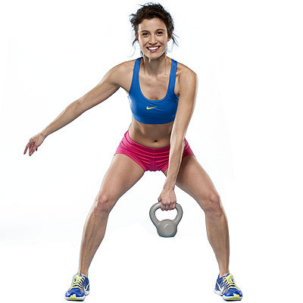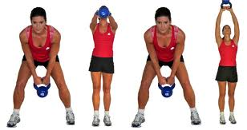
THE BENEFITS
As the long history of the Kettle bell proves, it has many benefits to offer those who use it on a regular basis. These benefits include:
- The building of ENDURANCE.
- TONING and STRENGTHENING of almost every muscle of the body.
- Stronger CORE.
- Increases FLEXIBILITY.
- Helps you to SHED FAT.
- Gives you the freedom to get an INTENSIVE WORKOUT from home.
The history of the Kettle bell is a long and proven record of its effectiveness. These unique exercise tools have been used by individuals around the world for hundreds of years to build muscle, lose fat, and strengthen their endurance. Now that the Kettle bells have been incorporated into everyday exercise routines, you can use them from the comfort of your home.
HIGHLIGHTS
It’s a BOOTYLICOUS workout
- KETTLE BELL DANCE to be performed in the swing section.
Let’s dance to the tune of Kettle bells.....

- TURKISH GET-UP: 12 Step Turkish Get-up for your core.

It’s BRUCELEE’S favourite workout tool.
Military Fighters, M.M.A personnel all of them use kettle bells to improve their endurance.

Duration:
Date:
Time:

